**DESIGN DB MODEL FOR GUVI ZEN CLASS**

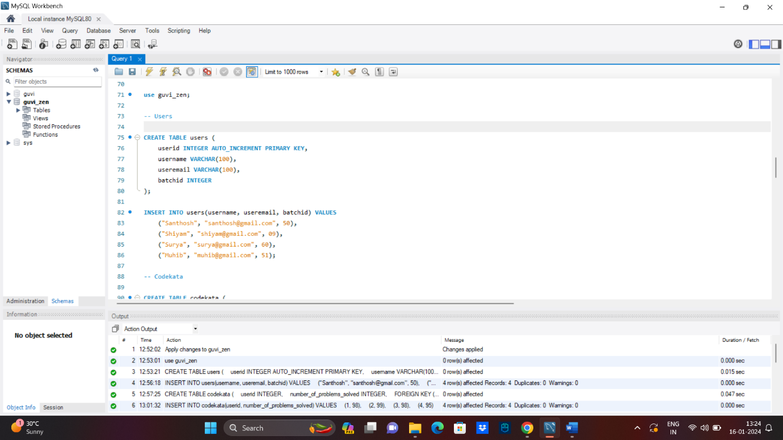

**use guvi_zen;**

**-- Users**

CREATE TABLE users (

userid INTEGER AUTO_INCREMENT PRIMARY KEY,

username VARCHAR(100),

useremail VARCHAR(100),

batchid INTEGER

);

INSERT INTO users(username, useremail, batchid) VALUES

("Santhosh", "santhosh@gmail.com", 50),

("Shiyam", "shiyam@gmail.com", 09),

("Surya", "surya@gmail.com", 60),

("Muhib", "muhib@gmail.com", 51);

**-- Codekata**

CREATE TABLE codekata (

userid INTEGER,

number_of_problems_solved INTEGER,

FOREIGN KEY (userid) REFERENCES users(userid)

);

INSERT INTO codekata(userid, number_of_problems_solved) VALUES

(1, 98),

(2, 99),

(3, 98),

(4, 95);

**-- Company drives**

CREATE TABLE company_drives (

driveid INTEGER AUTO_INCREMENT PRIMARY KEY,

userid INTEGER,

drive_date DATE,

company VARCHAR(100),

FOREIGN KEY (userid) REFERENCES users(userid)

);

INSERT INTO company_drives(userid, drive_date, company) VALUES

(2, "2024-01-05", "Apple"),

(3, "2024-05-19", "Amazon"),

(4, "2024-06-29", "Zomato"),

(1, "2024-09-01", "Flipkart");

**-- Mentors**

CREATE TABLE mentors (

mentorid INTEGER AUTO_INCREMENT PRIMARY KEY,

mentorname VARCHAR(100),

mentoremail VARCHAR(100)

);

INSERT INTO mentors(mentorname, mentoremail) VALUES

("SuryaKumar", "suryakumar@gmail.com"),

("Vijay", "Vijay@gmail.com"),

("Shaikh", "shaikh@gmail.com"),

("prabha", "prabha@gmail.com");

**-- Topics**

CREATE TABLE topics (

topicid INTEGER AUTO_INCREMENT PRIMARY KEY,

topic VARCHAR(200),

topic_date DATE,

mentorid INTEGER,

batchid INTEGER,

FOREIGN KEY (mentorid) REFERENCES mentors(mentorid)

);

INSERT INTO topics(topic, topic_date, mentorid, batchid) VALUES

("HTML - Basics", "2020-04-01", 1, 50),

("NodeJS - Basics", "2020-06-03", 2, 09),

("JavaScript - Basics", "2020-07-05", 3, 60),

("React - Basics", "2020-08-06", 4, 51);

**-- Tasks**

CREATE TABLE tasks (

taskid INTEGER AUTO_INCREMENT PRIMARY KEY,

topicid INTEGER,

task VARCHAR(1000),

batchid INTEGER,

FOREIGN KEY (topicid) REFERENCES topics(topicid)

);

INSERT INTO tasks(topicid, task, batchid) VALUES

(1, "HTML Task", 50),

(2, "Javascript Task", 09),

(3, "React Task", 60),

(4, "NodeJs Task", 51);

**-- Attendance**

CREATE TABLE attendance (

attendanceid INTEGER AUTO_INCREMENT PRIMARY KEY,

userid INTEGER,

topicsid INTEGER,

attended BOOLEAN,

FOREIGN KEY (userid) REFERENCES users(userid),

FOREIGN KEY (topicsid) REFERENCES topics(topicid)

);

INSERT INTO attendance(userid, topicsid, attended) VALUES

(2, 3, true),

(4, 1, true),

(1, 2, false),

(3, 4, true);

**-- Queries**

CREATE TABLE queries (

queryid INTEGER AUTO_INCREMENT PRIMARY KEY,

userid INTEGER,

querybody VARCHAR(1000),

mentorid INTEGER,

FOREIGN KEY (userid) REFERENCES users(userid),

FOREIGN KEY (mentorid) REFERENCES mentors(mentorid)

);

INSERT INTO queries(userid, querybody, mentorid) VALUES

(1, "query about HTML", 1),

(3, "query about Javascript",3),

(2, "query about React", 4),

(4, "query about DS", 2);

**EER DIAGRAM**

